Section 9-1: Reflections

SOL: G.2 The student will use pictorial representations, including computer software, constructions, and coordinate methods, to solve problems involving symmetry and transformation. This will include:
b) investigating symmetry and determining whether a figure is symmetric with respect to a line or a point; and
c) determining whether a figure has been translated, reflected, or rotated.

Objective:
Draw reflected images
Recognize and draw lines of symmetry and points of symmetry

Vocabulary:
Reflection – is a transformation representing a flip of a figure; figure may be reflected in a point, a line, or a plane.
Isometry – a congruence transformation (distance, angle measurement, etc preserved)
Line of symmetry – line of reflection that the figure can be folded so that the two halves match exactly
Point of symmetry – midpoint of all segments between the pre-image and the image; figure must have more than one line of symmetry
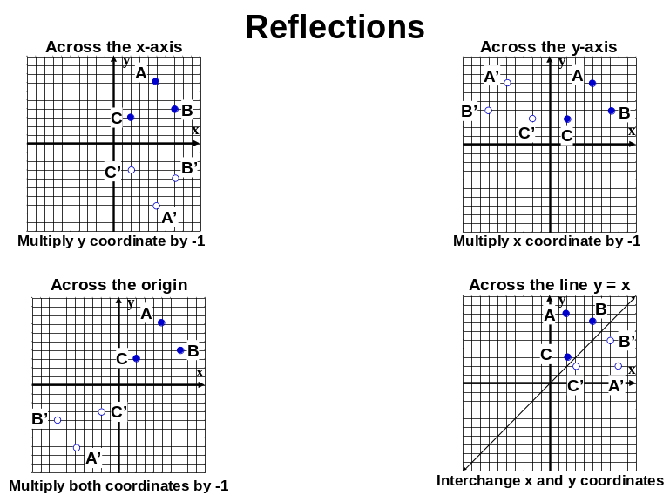
Concept Summary:

 | Common reflections in the coordinate plane
Reflection | x-axis | y-axis | origin | y = x
Pre-image to image | (a, b) ➔ (a, -b) | (a, b) ➔ (-a, b) | (a, b) ➔ (-a, -b) | (a, b) ➔ (b, a)
Find coordinates | Multiply y coordinate by -1 | Multiply x coordinate by -1 | Multiply both coordinates by -1 | Interchange x and y coordinates
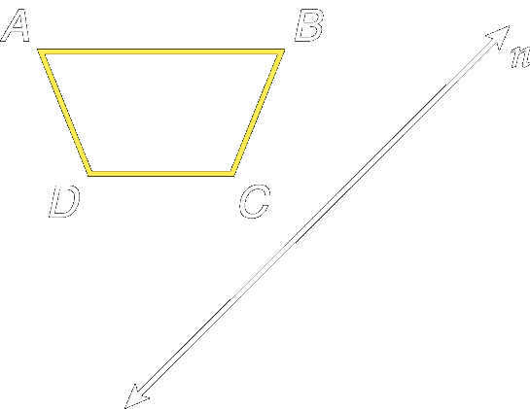
The line of symmetry in a figure is a line where the figure could be folded in half so that the two halves match exactly

Example 1: Draw the reflected image of
quadrilateral ABCD in line n.

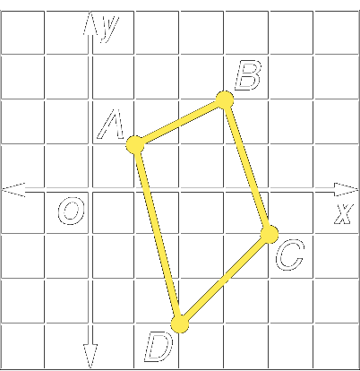
Example 1: Quadrilateral ABCD has vertices A(1, 1), B(3, 2), C(4, –1), and D(2, –3). Graph ABCD and its image under reflection in the x-axis. Compare the coordinates of each vertex with the coordinates of its image.

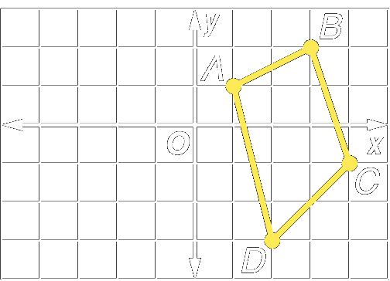
Example 2: Quadrilateral ABCD has vertices A(1, 1), B(3, 2), C(4, –1), and D(2, –3). Graph ABCD and its image under reflection in the y-axis. Compare the coordinates of each vertex with the coordinates of its image.

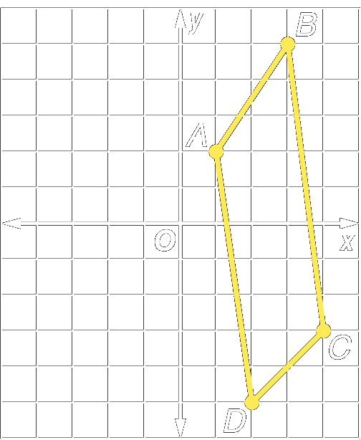
Example 3: Suppose quadrilateral ABCD with A(1, 2), B(3, 5), C(4, –3), and D(2, –5) is reflected in the origin. Graph ABCD and its image under reflection in the origin. Compare the coordinates of each vertex with the coordinates of its image.

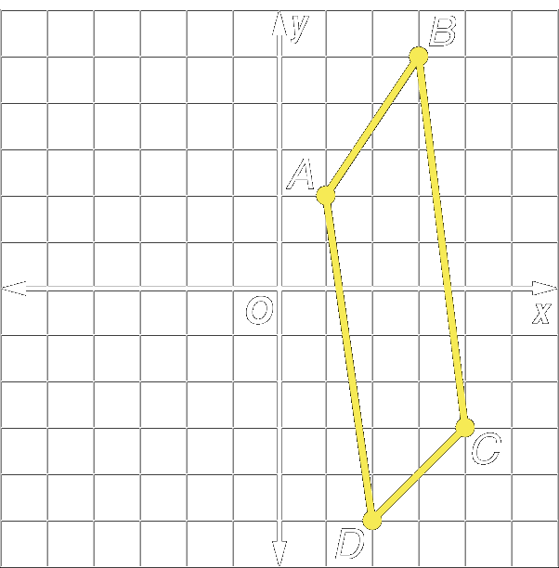

Example 4: Suppose quadrilateral ABCD with A(1, 2), B(3, 5), C(4, –3), and D(2, –5) is reflected in the line y = x. Graph ABCD and its image under reflection in the line y = x. Compare the coordinates of each vertex with the coordinates of its image.

Homework: pg 467-469; 15-17, 28-30, 35-36, 44-47
Section 9-2: Translations

SOL: G.2 The student will use pictorial representations, including computer software, constructions, and coordinate methods, to solve problems involving symmetry and transformation. This will include:
c) determining whether a figure has been translated, reflected, or rotated.

Objective:
Draw translated images using coordinates
Draw translated images by using repeated reflections

Vocabulary:
Translation – transformation that moves all points of a figure the same distance in the same direction
Composition – transformation made up of successive transformations (even number)

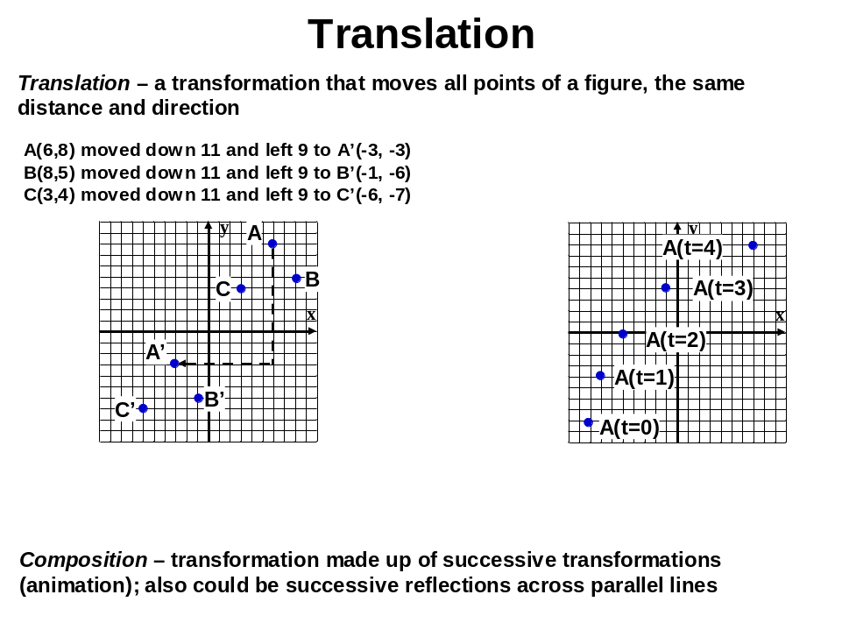

Concept Summary:
A translation moves all points of a figure the same distance in the same direction
A translation can be represented as a composition of reflections

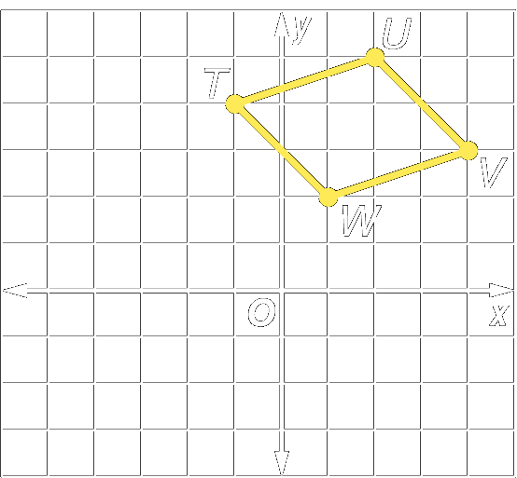
Example 1: Parallelogram TUVW has vertices T(–1, 4), U(2, 5), V(4, 3), and W(1, 2). Graph TUVW and its image for the translation (x, y) → (x – 4, y – 5).

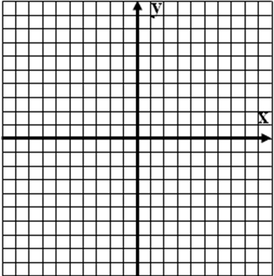
Example 2: Parallelogram LMNP has vertices L(–1, 2), M(1, 4), N(3, 2), and P(1, 0). Graph LMNP and its image for the translation (x, y) → (x + 3, y – 4).

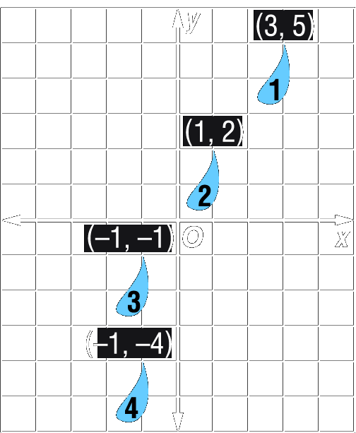
Example 3: The graph shows repeated translations that result in the animation of a raindrop. Find the translation that moves raindrop 2 to raindrop 3 and then the translation that moves raindrop 3 to raindrop 4.

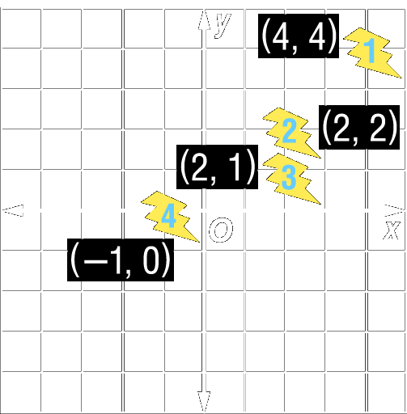
Example 4: The graph shows repeated translations that result in the animation of a lightning bolt. Find the translation that moves lightning bolt 3 to lightning bolt 4 and then the translation that moves lightning bolt 2 to lightning bolt 1.

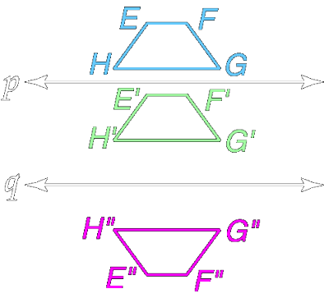
Example 5: In the figure, lines p and q are parallel. Determine whether the bottom figure is a translation image of the top preimage, quadrilateral EFGH.

Homework: pg 472-474; 8-10, 12-13, 17-19, 27
Section 9-3: Rotations

SOL: G.2 The student will use pictorial representations, including computer software, constructions, and coordinate methods, to solve problems involving symmetry and transformation. This will include: ……
c) determining whether a figure has been translated, reflected, or rotated.

Objective:
Draw rotated images using the angle of rotation
Identify figures with rotational symmetry

Vocabulary:
Rotation – transformation that turns every point of a pre-image through a specified angle and direction about a fixed point
Center of rotation – fixed point of the rotation
Angle of rotation – angle between a pre-image point and corresponding image point
Rotational symmetry – a figure can be rotated less than 360° so that the pre-image and image look the same (indistinguishable)
Order – number of times figure can be rotated less than 360° in above
Magnitude – angle of rotation (360° / order)

Key Concept:
Postulate 9.1 – In a given rotation, if A is the pre-image, A” is the image, and P is the center of rotation, then the measure of the angle of rotation ∠APA” is twice the measure of the acute or right angle formed by the intersecting lines of reflection.

Corollary 9.1 – Reflecting an image successively in two perpendicular lines results in a 180° rotation
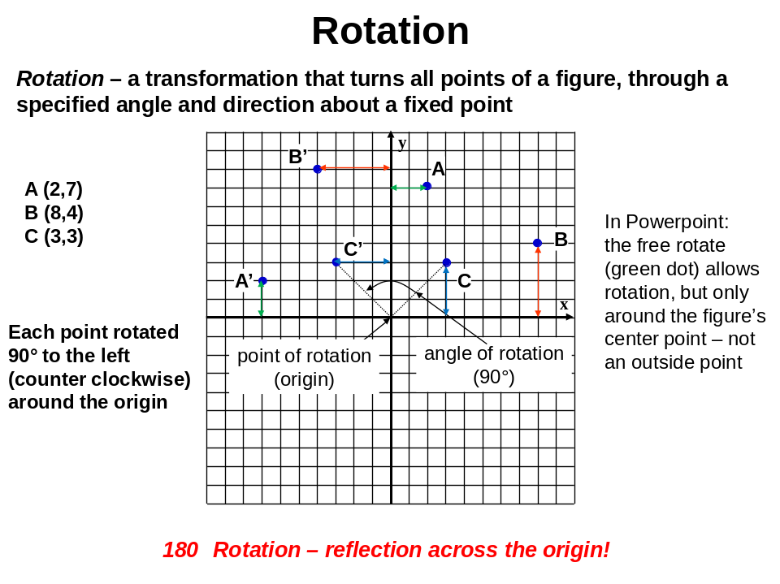
Concept Summary:
A rotation turns each point in a figure through the same angle about a fixed point
An object has rotational symmetry when you can rotate it less than 360° and the pre-image and the image are indistinguishable (can’t tell them apart)
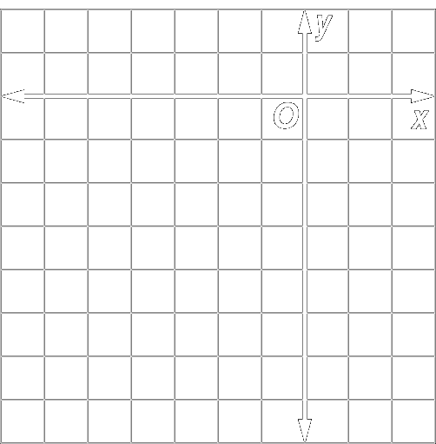
Example 1: Triangle DEF has vertices D(–2, –1), E(–1, 1), and F(1, –1). Draw the image of ΔDEF under a rotation of 115° clockwise about the point G(–4, –2).

Example 2: Triangle ABC has vertices A(1, –2), B(4, –6), and C(1, –6). Draw the image of ΔABC under a rotation of 70° counterclockwise about the point M(–1, –1).

Example 3: Use the quilt by Judy Mathieson shown to the right. Identify the order and magnitude of the symmetry in the medium star directly to the left of the large star in the center of the quilt.

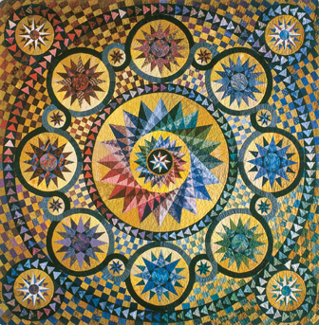

Example 4: Identify the order and magnitude of the symmetry in the tiny star above the medium-sized star in Example 3a.

Example 5: Identify the order and magnitude of the symmetry in each part of the quilt.

Example 6: Rotational Symmetry – find the rotational order and magnitude of the following figures:

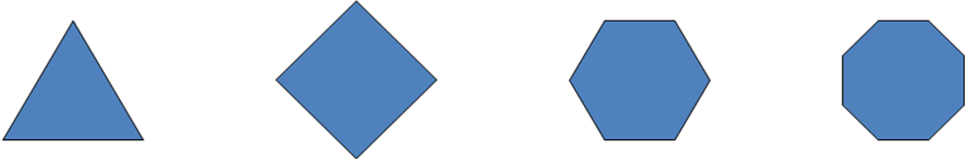

Homework: pg 479-481; 9, 10, 14, 15, 23, 41
Section 9-4: Tessellations

SOL: G.9 The student will use measures of interior and exterior angles of polygons to solve problems. Tessellations and tiling problems will be used to make connections to art, construction, and nature.

Objective:
Identify regular tessellations
Create tessellations with specific attributes

Vocabulary:
Tessellation – a pattern that covers a plan by transforming the same figure or set of figures so that there are no overlapping or empty spaces
Regular tessellation – formed by only one type of regular polygon (the interior angle of the regular polygon must be a factor of 360 for it to work)
Semi-regular tessellation – uniform tessellation formed by two or more regular polygons
Uniform – tessellation containing same arrangement of shapes and angles at each vertex

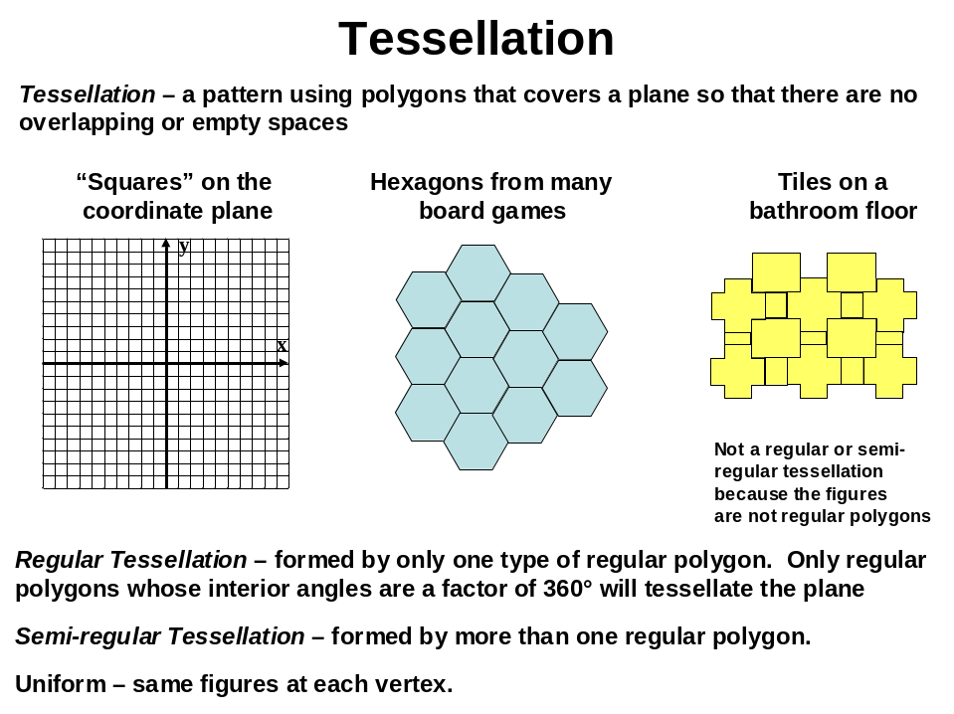

Concept Summary:
A tessellation is a repetitious pattern that covers a plane without overlap
A uniform tessellation contains the same combination of shapes and angles at every vertex

Example 1: Determine whether a regular 16-gon tessellates the plane. Explain.

Example 2: Determine whether a regular 20-gon tessellates the plane. Explain.

Example 3: Determine whether a semi-regular tessellation can be created from regular nonagons and squares, all having sides 1 unit long.

Example 4: Determine whether a semi-regular tessellation can be created from regular hexagon and squares, all having sides 1 unit long. Explain.

Example 5: Stained glass is a very popular design selection for church and cathedral windows. It is also fashionable to use stained glass for lampshades, decorative clocks, and residential windows. Determine whether the pattern is a tessellation. If so, describe it as uniform, regular, semi-regular, or not uniform.

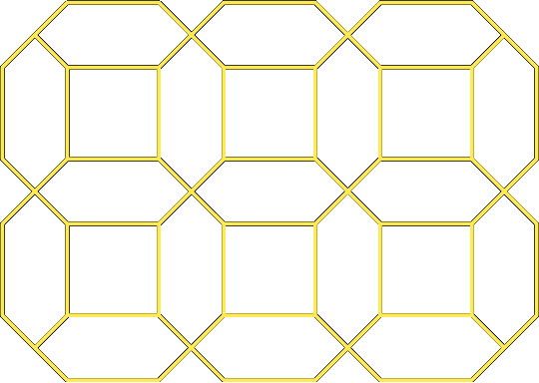

Example 6: Stained glass is a very popular design selection for church and cathedral windows. It is also fashionable to use stained glass for lampshades, decorative clocks, and residential windows. Determine whether the pattern is a tessellation. If so, describe it as uniform, regular, semi-regular, or not uniform



Homework: pg 486-487; 11-15, 19, 20, 26-28, 37
Section 9-5: Dilations

SOL: G.2 The student will use pictorial representations, including computer software, constructions, and coordinate methods, to solve problems involving symmetry and transformation. This will include: ……
c) determining whether a figure has been translated, reflected, or rotated.

Objective:
Determine whether a dilation is an enlargement, a reduction, or a congruence transformation

Vocabulary:
Dilation – a transformation that may change the size of a figure

Theorems:

Theorem 9.1: If a dilation with center C and a scale factor of r transforms A to E and B to D, the ED = |r|·(AB)
Theorem 9.2: If P(x, y) is the pre-image of a dilation centered at the origin with a scale factor r, then the image is P’(rx, ry)
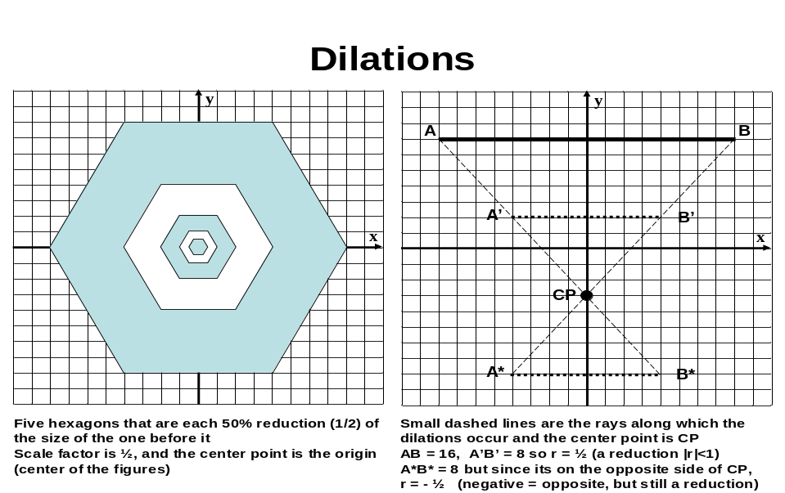
Key Concept:
If |r| > 1, then the dilation is an enlargement
If 0 < |r| < 1, then the dilation is a reduction
If |r| = 1, then the dilation is a congruence transformation
If r > 0, then the new point P’ list on the ray CP (where C is the center) and CP’ = r · CP
If r < 0, then P’ lies on ray CP’ (ray opposite CP), and CP’ = |r| · CP

Concept Summary:
Dilations can be enlargements, reductions, or congruence transformations

Example 1: Find the measure of the dilation image CD if CD = 15, and r = 3.

Example 2: Find the measure of CD if C’D’ = 7, and r = - ⅔.

Example 3: Find the measure of the dilation image or the preimage of AB using the given scale factor.
- If AB = 15 and r = -2
- If A’B’ = 24 and r = ⅔

Example 4: Draw the dilation image of trapezoid PQRS with center C and r = - 3

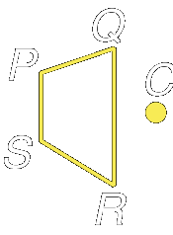

Example 5: Determine the scale factor used for the dilation with center C. Determine whether the dilation is an enlargement, reduction, or congruence transformation. The light color is the preimage.

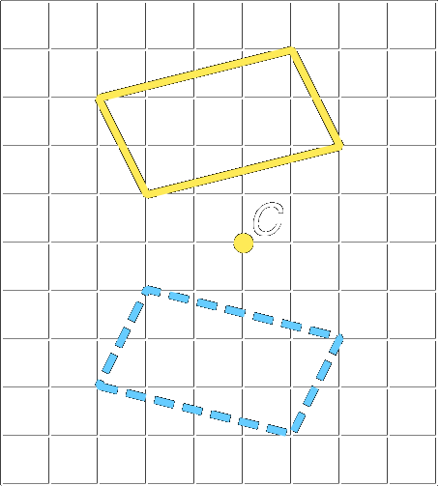
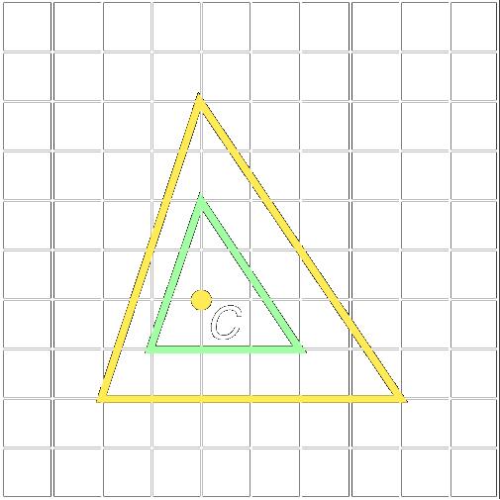
- b) c)
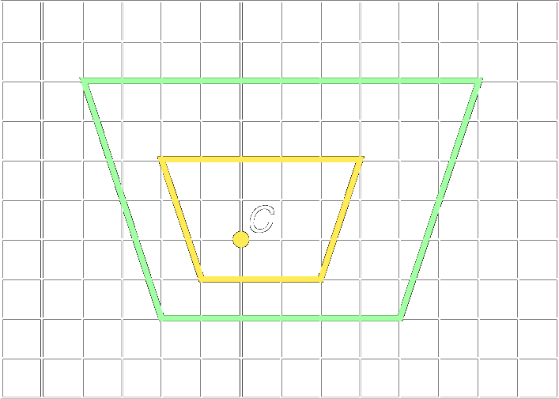

Homework: pg 494-496; 14, 15, 20-23, 30-35
Section 9-6: Vectors

SOL: G.7 The student will solve practical problems involving right triangles by using the Pythagorean Theorem, properties of special right triangles, and right triangle trigonometry. Solutions will be expressed in radical form or as decimal approximations.

Objective:
Find magnitudes and directions of vectors
Perform translations with vectors

Vocabulary:
Vector – a quantity that has both magnitude and direction
Vector magnitude – its length (use distance formula to find magnitude)
Vector direction – measure of angle the vector forms with x-axis
Component form – ordered pair representation of a vector (∆x, ∆y)
Resultant – the sum of two vectors
Scalar – a positive constant
Scalar multiplication – multiplying a vector by a scalar

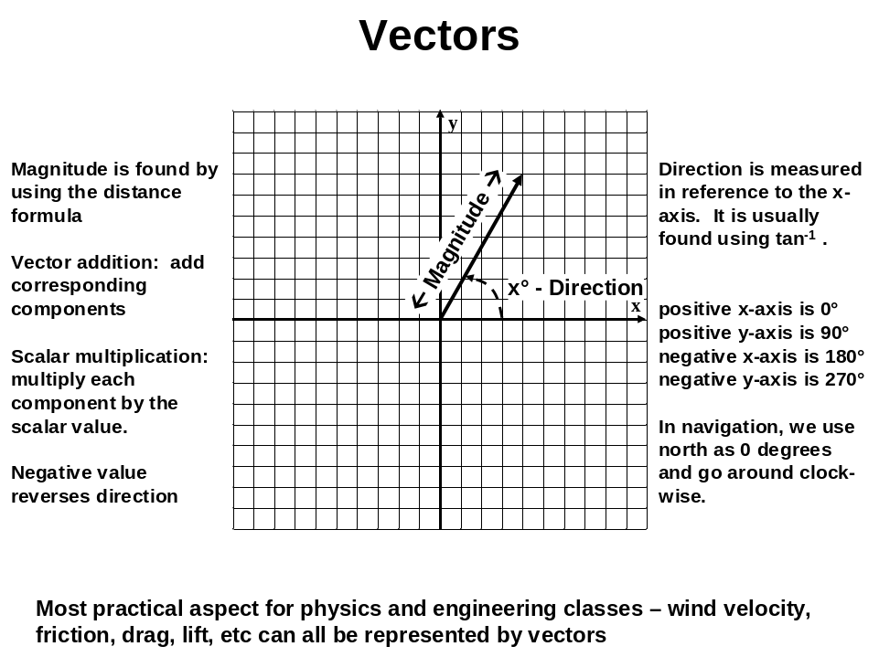

Concept Summary:
A vector is a quantity with both magnitude and direction
Vectors can be used to translate figures on the coordinate plane
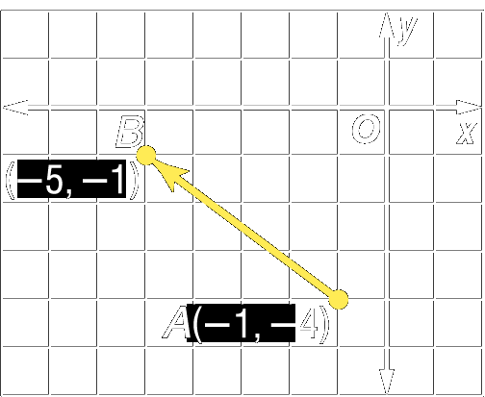
Example 1: Write component form of vector AB

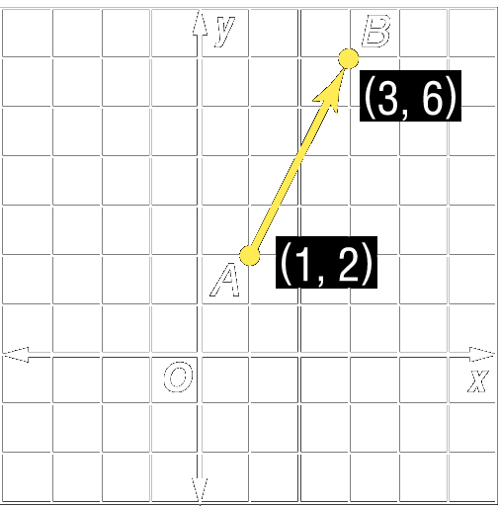
Example 2: a) Write component form of vector AB

- Find its magnitude:

Example 3: Find the magnitude and direction of Vector ST if S(–3, –2) and T(4, –7).

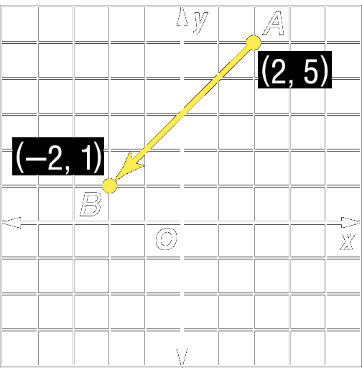

Example 4: Find the magnitude and direction of vector AB if A(2, 5) and B(–2, 1).

Example 5: Graph the image of triangle ABC with vertices A(7, 6), B(6, 2), and C(2, 3) under the translation of vector v <-3,-4>

Example 6: Suppose a person is canoeing due east across a river at 4 miles per hour. If the river is flowing south at 3 miles an hour, what is the resultant direction and velocity of the canoe?

Homework: pg 503-504; 15-17, 24-28, 47-50
Lesson 9-1 5 Minute Review:
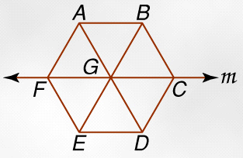
Name the reflected image of each figure in line m
- BC
- AB
- ∆AGB
- B
- ABCF
6. How many lines of symmetry are in an equilateral triangle?
A. 1 B. 2 C. 3 D. 4

Lesson 9-2 5 Minute Review:
Find the coordinates of each figure under the given translation.
- RS with endpoints R(1,-3) and S(-3,2) under the translation right 2 units and down 1 unit.

- Quadrilateral GHIJ with G(2,2), H(1,-1), I(-2,-2), and J(-2,5) under the translation left 2 units and down 3 units.

- ∆ABC with vertices A(-4,3), B(-2,1), and C(0,5) under the translation (x, y) à (x + 3, y – 4)

- Trapezoid LMNO with vertices L(2,1), M(5,1), N(1,-5), and O(0-2) under the translation (x, y) à (x – 1, y + 4)

- Find the translation that moves AB with endpoints A(2,4) and B(-1,-3) to A’B’ with endpoints A’(5,2) and B’(2,-5)

- Which describes the translation left 3 units and up 4 units?
A. (x, y) à (x + 3, y – 4) B. (x, y) à (x – 3, y – 4) C. (x, y) à (x + 3, y + 4) D. (x, y) à (x – 3, y + 4)

Lesson 9-3 5 Minute Review:
Find the coordinates of each figure under the given translation.
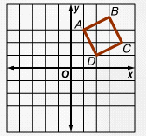
Identify the order and magnitude of rotational symmetry for each regular polygon.
1. Triangle 2. Quadrilateral

3. Hexagon 4. Dodecagon

5. Draw the image of ABCD under a 180° clockwise rotation about the origin?

6. If a point at (-2,4) is rotated 90° counter clockwise around the origin, what are its new coordinates?
A. (– 4, – 2) B. (– 4, 2) C. (2, – 4) D. (– 2, – 4)

Lesson 9-4 5 Minute Review:
Determine whether each regular polygon tessellates the plane. Explain
- Quadrilateral

- octagon

- 15 -gon

Determine whether a semi-regular tessellation can be created from each figure. Assume each figure has a side length of 1 unit.
4. triangle and square 5. pentagon and square

6. Which regular polygon will not tessellate the plane?
A. triangle B. quadrilateral C. pentagon D. hexagon

Lesson 9-5 5 Minute Review:
Determine whether the dilation is an enlargement, a reduction or a congruence transformation based on the given scaling factor.
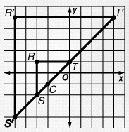
- r = ⅔ 2. r = - 4 3. r = 1

Find the measure of the dilation image of AB with the given scale factor
4. AB = 3, r = - 2 5. AB = 3/5, r = 5/7

6. Determine the scale factor of the dilated image

Lesson 9-6 5 Minute Review:
Write the component form of each vector
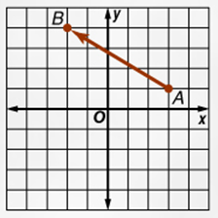
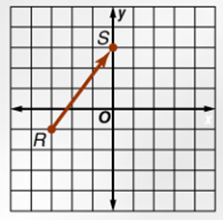

Find the magnitude and direction of vector AB for the given coordinates. Round to the nearest tenth.
3. A(-3, -2), B(5, 1) 4. A(2, 6), b(-2, 0)

5. Find the magnitude and direction of the resultant vector for a = <3, 4> and b = <-2, 1>

6. Find the magnitude of the resultant for u = <-3, 2> and v = <-4, 4>
A. √3 B. √34 C. √85 D. √89

